QHHS Live Tutoring
- Need help with your homework?
- Need help with a major essay?
- Need help with PSAT, SAT, ACT, or AP Exams?

Access live tutors in subjects such as: Math, English, Science, Foreign Language, Social Studies, and more!

- Go to https://powerschool.avhsd.org
- Sign in using your student user ID and password
- Select “Live Tutors” on the left side menu
- Sign in using your Google email and PowerSchool password
- Go to https://powerschool.avhsd.org
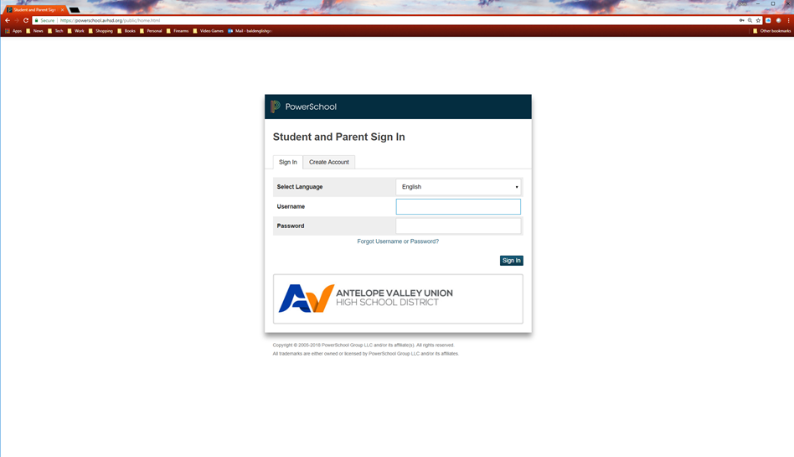
- Sign in using your student user ID and password

- Select “Live Tutors” on the left side menu
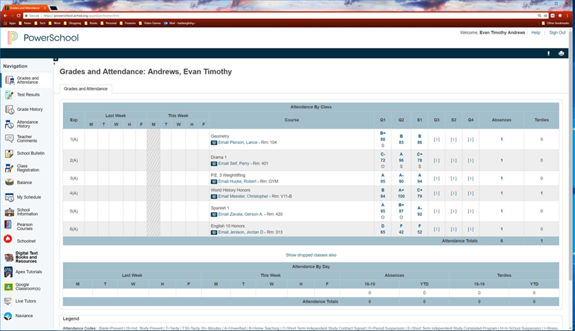

- If needed, sign in using your student Google email and PowerSchool password
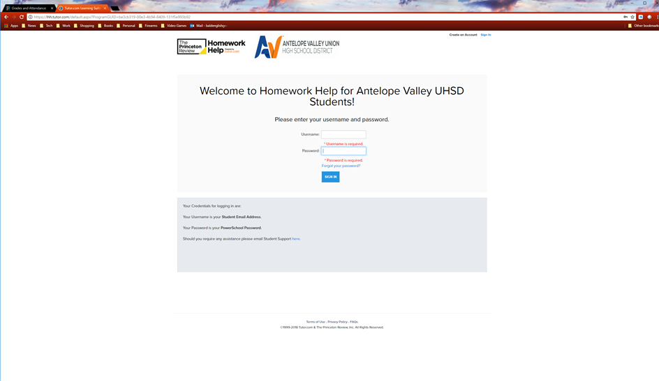

- From here you can:
- Connect with a live tutor  - Schedule a tutoring session  - Submit papers for comments/help | - Take practice exams  - Prep for PSAT, SAT, ACT, and AP Exams
