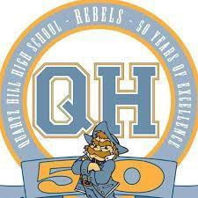
QHHS GIRL’S GOLF ROSTER - 2019

NAME YEAR IN SCHOOL
- ALYSHA DIJAMCO 12
- EME LARSEN 12
- MADISON SCHAFER 12
- HALLE BOULGER 12
- SHEEHWA YOU 12
- EMMA ARMENDARIZ 12
- KAMBRIE MILLER 12
- MERRIT KANGA 11
- VANI TYAGI 11
- MICHELLE HESS 11
- YEO KIM 11
- PAYTON SAUCIER 10
- KYLIE WARNER 09
- TAYLOR WATERS 09
- TERRY MULLER 09
- SAMANTHA REDIFER 09

Coaches: Dan Pratt
Kevin Mahady

