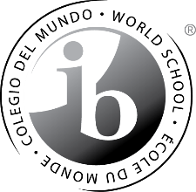

DECLARATION OF INTENT
TO FULFILL ALL REQUIREMENTS FOR IB DIPLOMA CANDIDACY
AT QUARTZ HILL HIGH SCHOOL

This document is a formal Declaration of Intent committing the student to completion of all qualifying requirements necessary to be eligible for the IB Diploma. This document will serve as a formal commitment to complete the following requirements:

- Completion and passing of all IB Higher Level (HL) and Standard Level (SL) classes.
- Completion of IB examination papers in six curricular areas.
- Completion of the Creativity, Action and Service requirement.
- Completion of the Theory of Knowledge course.
- Completion of the required Extended Essay of 4,000 words.

These requirements are official requirements mandated by the International Baccalaureate Organization (IBO), and must be completed by each student in order to receive the IB Diploma.

It is the expectation of the Antelope Valley Union High School District that by signing this Declaration of Intent, the student and his/her parent(s) or guardian(s) understand that the student will complete these requirements.

______________________________________________ ____________________
Student Date

______________________________________________ _____________________
Parent/Guardian Date

